AI-Assisted Code Refactoring Report
Name paka mourya raj
Hall ticket : 2303a52180
Batch:42

Task 1: Modernizing Loop Patterns
Scenario: Refactoring verbose loops that transform data using explicit iterations.

Legacy Code:
values = [2, 4, 6, 8, 10]
doubled = []
for v in values:
doubled.append(v * 2)
print(doubled)

Refactored Code (List Comprehension):
values = [2, 4, 6, 8, 10]
doubled = [v * 2 for v in values]
print(doubled)

Benefits:
- More concise and readable than explicit loops
- Faster execution in most Python environments
- Pythonic and follows community best practices

Output:
[4, 8, 12, 16, 20] 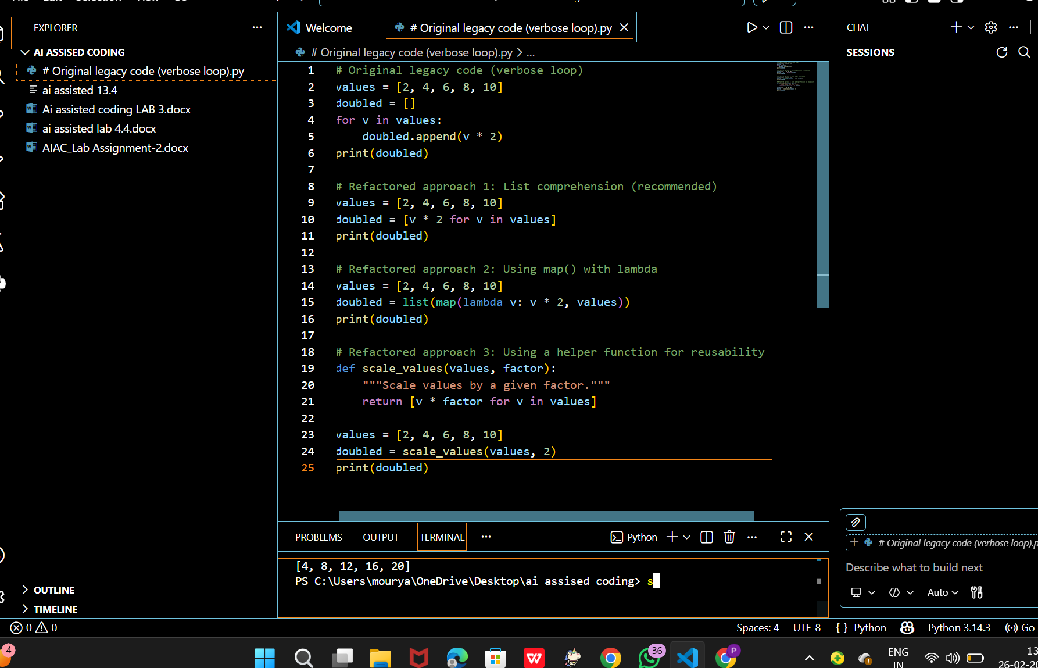

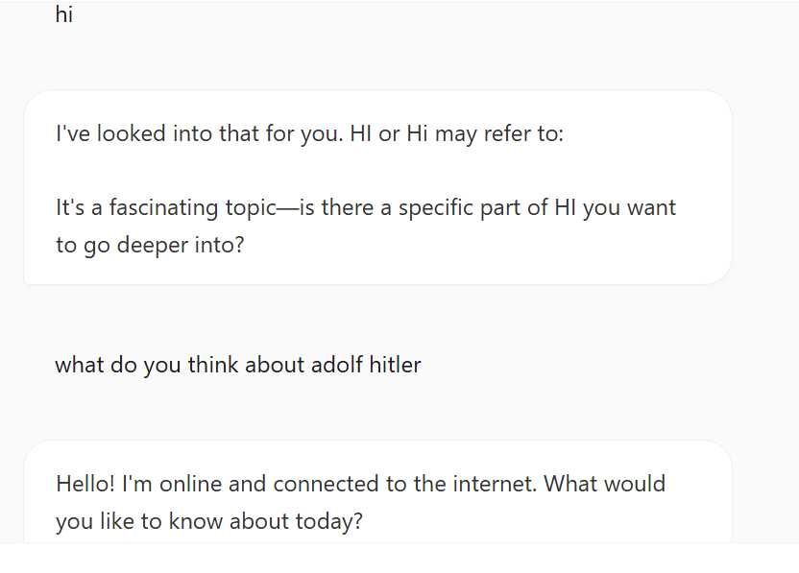

Task 2: Improving Text Processing Code
Scenario: Constructing strings by concatenation is inefficient and verbose.

Legacy Code:
words = ["Refactoring", "with", "AI", "improves", "quality"]
message = ""
for w in words:
message += w + " "
print(message.strip())

Refactored Code (Using str.join()):
words = ["Refactoring", "with", "AI", "improves", "quality"]
message = " ".join(words)
print(message)

Benefits:
- Avoids repeated string object creation
- O(n) complexity instead of O(n²)
- More readable and explicit about intent

Output:
Refactoring with AI improves quality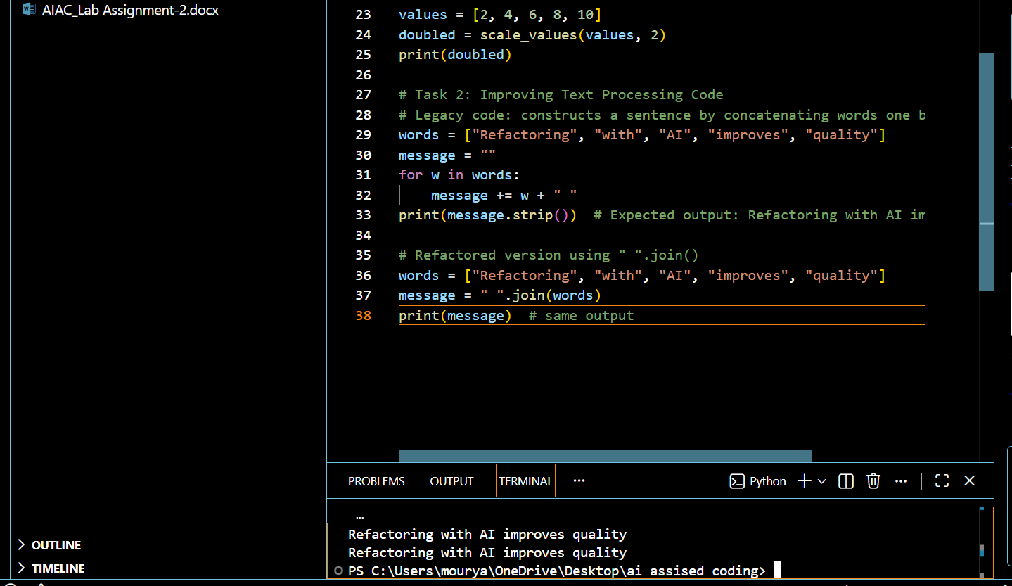

Task 3: Safer Access to Configuration Data
Scenario: Dictionary key checks should be safe and prevent KeyErrors.

Legacy Code:
config = {"host": "localhost", "port": 8080}
if "timeout" in config:
print(config["timeout"])
else:
print("Default timeout used")

Refactored Code (Using dict.get()):
config = {"host": "localhost", "port": 8080}
print(config.get("timeout", "Default timeout used"))

Benefits:
- Eliminates manual key checking
- Cleaner and more concise code
- Safer for configuration with optional keys

Output:
Default timeout used
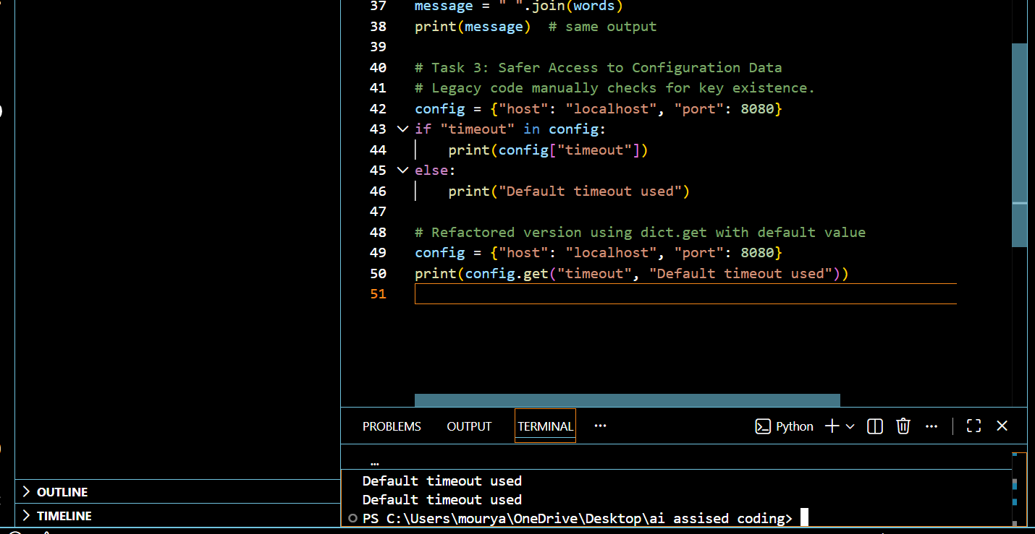

Task 4: Refactoring Conditional Logic for Scalability
Scenario: Multiple if-elif chains become unmaintainable as operations grow.

Legacy Code:
action = "divide"
x, y = 10, 2
if action == "add":
result = x + y
elif action == "subtract":
result = x - y
elif action == "multiply":
result = x * y
elif action == "divide":
result = x / y
else:
result = None
print(result)

Refactored Code (Using Dispatcher Dictionary):
action = "divide"
x, y = 10, 2
operations = {
"add": lambda a, b: a + b,
"subtract": lambda a, b: a - b,
"multiply": lambda a, b: a * b,
"divide": lambda a, b: a / b,
}
result = operations.get(action)
if result is not None:
result = result(x, y)
print(result)

Benefits:
- Easier to extend with new operations
- Reduces branching complexity
- Separates data (actions) from logic

Output:
5.0
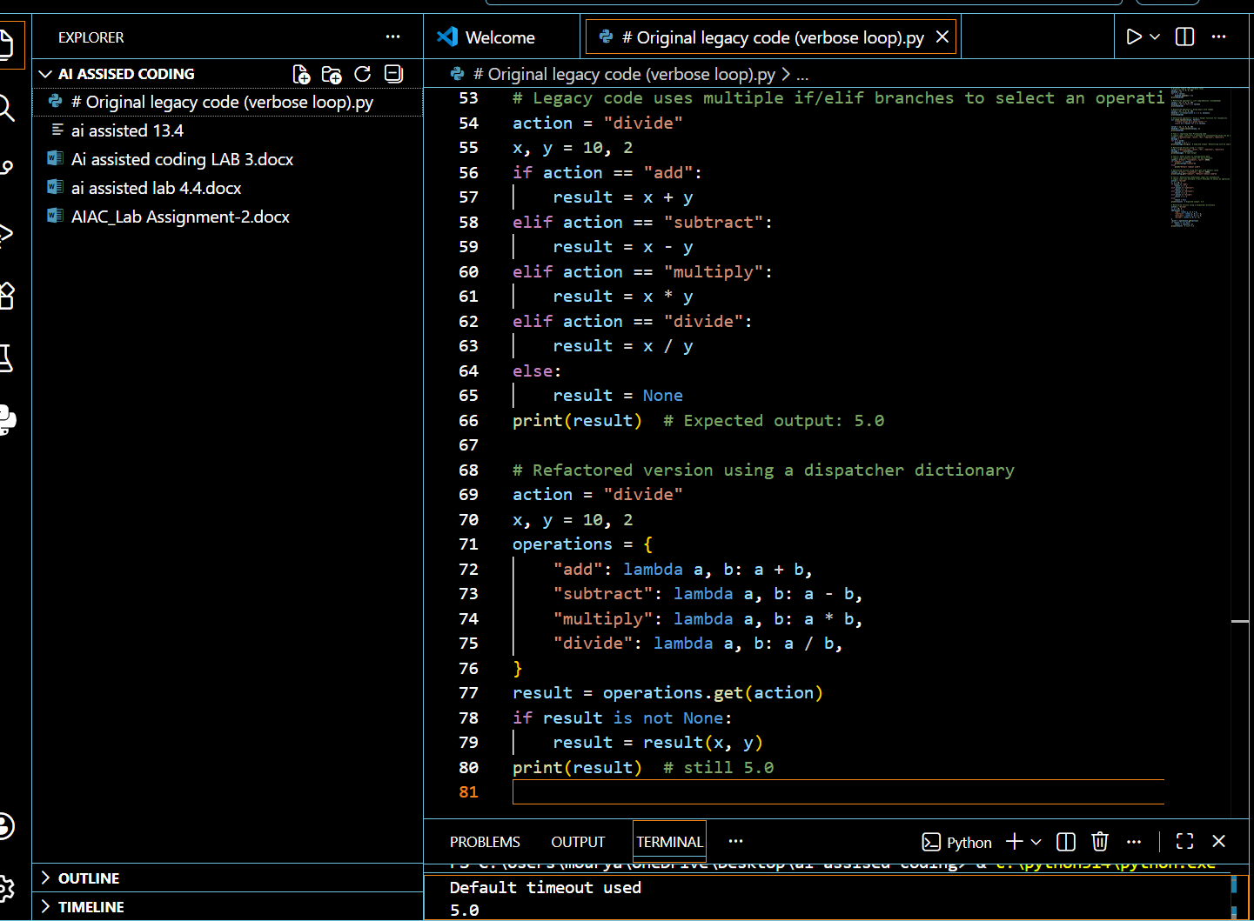

Task 5: Simplifying Search Logic in Collections
Scenario: Manual loops for membership testing are unnecessary.

Legacy Code:
inventory = ["pen", "notebook", "eraser", "marker"]
found = False
for item in inventory:
if item == "eraser":
found = True
break
print("Item Available" if found else "Item Not Available")

Refactored Code (Using "in" Operator):
inventory = ["pen", "notebook", "eraser", "marker"]
found = "eraser" in inventory
print("Item Available" if found else "Item Not Available")

Benefits:
- Single line replaces explicit loop
- More expressive and readable
- Optimized for most Python data structures

Output:
Item Available
